GUESTS OF THE MONTH/December 2025
Sabrina Tsui, Manager of Resource Development
Ben Wong, Manager of Strategic Planning, & Kharla Pimentel (Presenter)
Water Resources Division
Los Angeles Department of Water & Power

2025 URBAN WATER MANAGEMENT PLAN (UWMP)
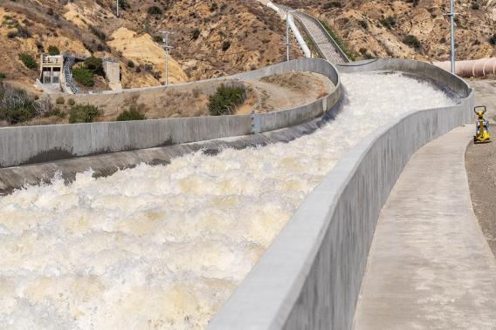
Summary by Robert Yoshimura

A severe drought in California in the late 1970s overwhelmed the state’s water agencies and exposed their lack of preparedness for such climate events. In response, the state’s leaders enacted the Urban Water Management Planning Act of 1983 which requires each water agency serving more than 3,000 customers or 3,000 AF/Y of water to submit an UWMP every five years that includes the following information:
LADWP UWMP Website
- An assessment of the reliability of water sources over a 20-year or 25-year (optional) planning time frame
- A description of demand management measures
- A discussion of the use and planned use of recycled water
- A water shortage contingency plan

The plan must be submitted to the California Department of Water Resources by July 2026 and is required to qualify for state loans and grants, of which LADWP has received and will continue to receive hundreds of millions of dollars for its ongoing and future projects. The UWMP will consolidate multiple planning efforts into a single plan that looks forward 25 years. LADWP has chosen the optional 5 years, so the 2025 UWMP will extend through 2050. The last UWMP for Los Angeles was completed in 2020

Water supply reliability is assessed under four scenarios: Long-term assessments (2025 -2050 in five-year increments) must include average year hydrology, single dry year hydrology, and multiple dry year (5 years) hydrology. A near-term assessment (2025-2030 in one-year increments) must include a drought risk assessment for that time span.

Water demand in Los Angeles has steadily declined from 650,000 Acre-Feet per Year (AFY) in 2000 to less than 450,000 AFY today due largely to declines in per capita consumption. Demand forecasts reflect these trends and anticipate gradually rising total water use over the next 25 years. The rising usage reflects the impact of expected population growth which will partially offset the declines in per capita consumption. Population forecasts developed by the Southern California Association of Governments (SCAG) show a slower growth rate today compared to their forecasts in 2020, and a lower starting point reflecting the significant decline in population between 2019 and 2023. The current forecast predicts a population in 2045 of 4.3 million people compared to nearly 4.9 million forecasted five years ago.

A new component of UWMPs added by regulatory action in January 2025 are the Urban Water Use Objectives (UWUO) which require the development of water budgets for several categories of use. The categories include indoor and outdoor residential budgets, commercial, industrial, and institutional dedicated-irrigation-meter water budgets, water loss budgets, and any applicable adjustments. The budgets for each category are targets expected to be met by 2030.

LADWP is fortunate to have a large and diverse portfolio of water sources to draw from including the Los Angeles Aqueduct, the Colorado River Aqueduct, the State Water Project, Local Groundwater, and other sources such as recycled water, conservation, and stormwater capture. However, each source has its challenges that must be addressed. LADWP has partnered with UCLA to assess the water supply conditions affecting the LA Aqueduct. That assessment has concluded that the eastern California region is most likely to experience climate change impacts compared to the other sources. These impacts will require focused planning to mitigate their impacts and accommodate specific strategies into LADWP’s operating plans.

The Colorado River is facing the expiration of the Interim Operating Guidelines next year and MWD is working to formulate and negotiate new permanent guidelines in the coming few months. The State Water Project is facing uncertainties regarding its future operations and recently published a report addressing those uncertainties. Groundwater contamination in the San Fernando Basin has been a long-term problem for which the completion of treatment facilities this year will enable LADWP to again extract its full allotment of water after more than 25 years of limited usage.

LADWP has been developing the Groundwater Replenishment Project (GWRP) that will take highly treated reclaimed water from the Tillman Reclamation Plant in the southwest corner of the San Fernando Valley and pump it to the Hansen Spreading Grounds in the northeast part of the Valley. The GWRP is now under construction and when completed it will increase the amount of groundwater available for pumping into the distribution system.

Pure Water Los Angeles is another water recycling project now in the planning stages that will enable reuse of most of the effluent from the City’s Hyperion Water Reclamation Plant. This ambitious project will significantly increase the water supply for Los Angeles while significantly decreasing the discharge of wastewater into Santa Monica Bay. The Master Plan for Pure Water Los Angeles was released in March 2025, and a programmatic environmental impact report is now in development.

A final requirement is the Water Shortage Contingency Plan that is a stand-alone document to be included in the UWMP. That document was created by LADWP and includes 1) a process to identify and respond to shortages, 2) establishes six water shortage levels, and 3) identifies response actions that may be implemented to respond to shortages.

The 2025 UWMP is still in development. In 2025, the development process has included coordination meetings with MWD and stakeholder outreach efforts to gain broad input into the plan. The draft UWMP will be released early in 2026, followed by public hearings and a public comment period. The plan will subsequently be finalized and submitted to the Department of Water Resources by July 1, 2026.

